Transformation template group
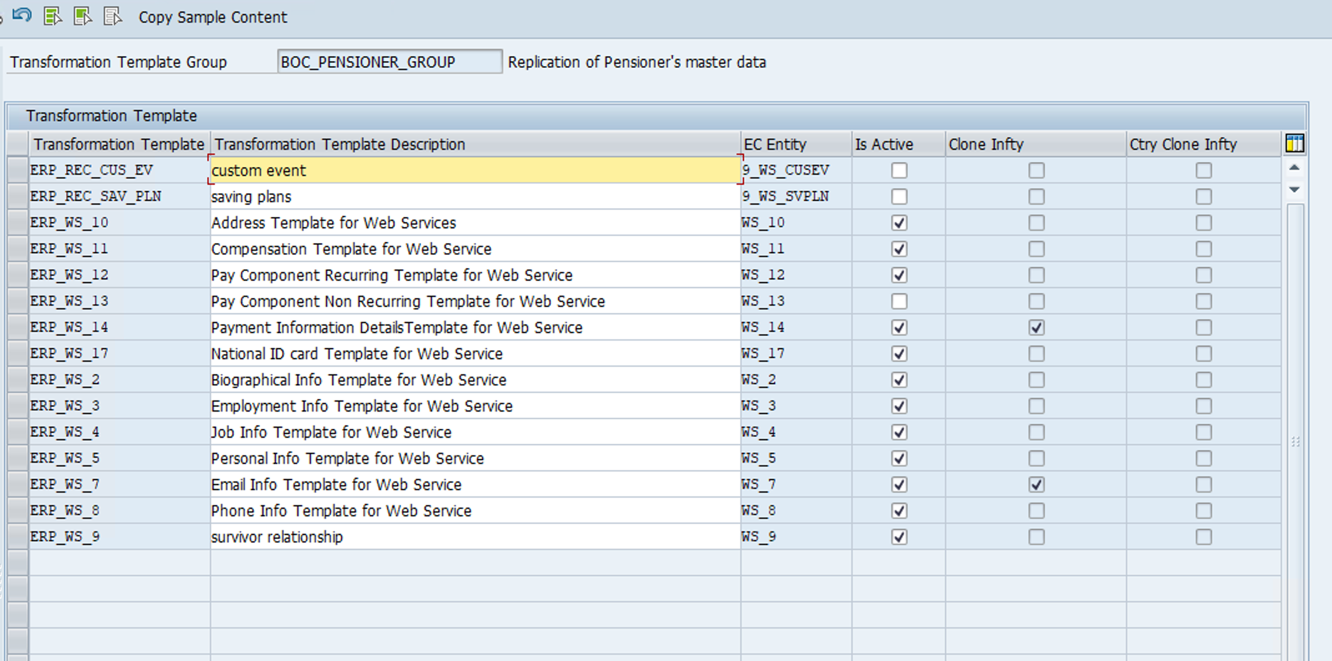
Ws 10
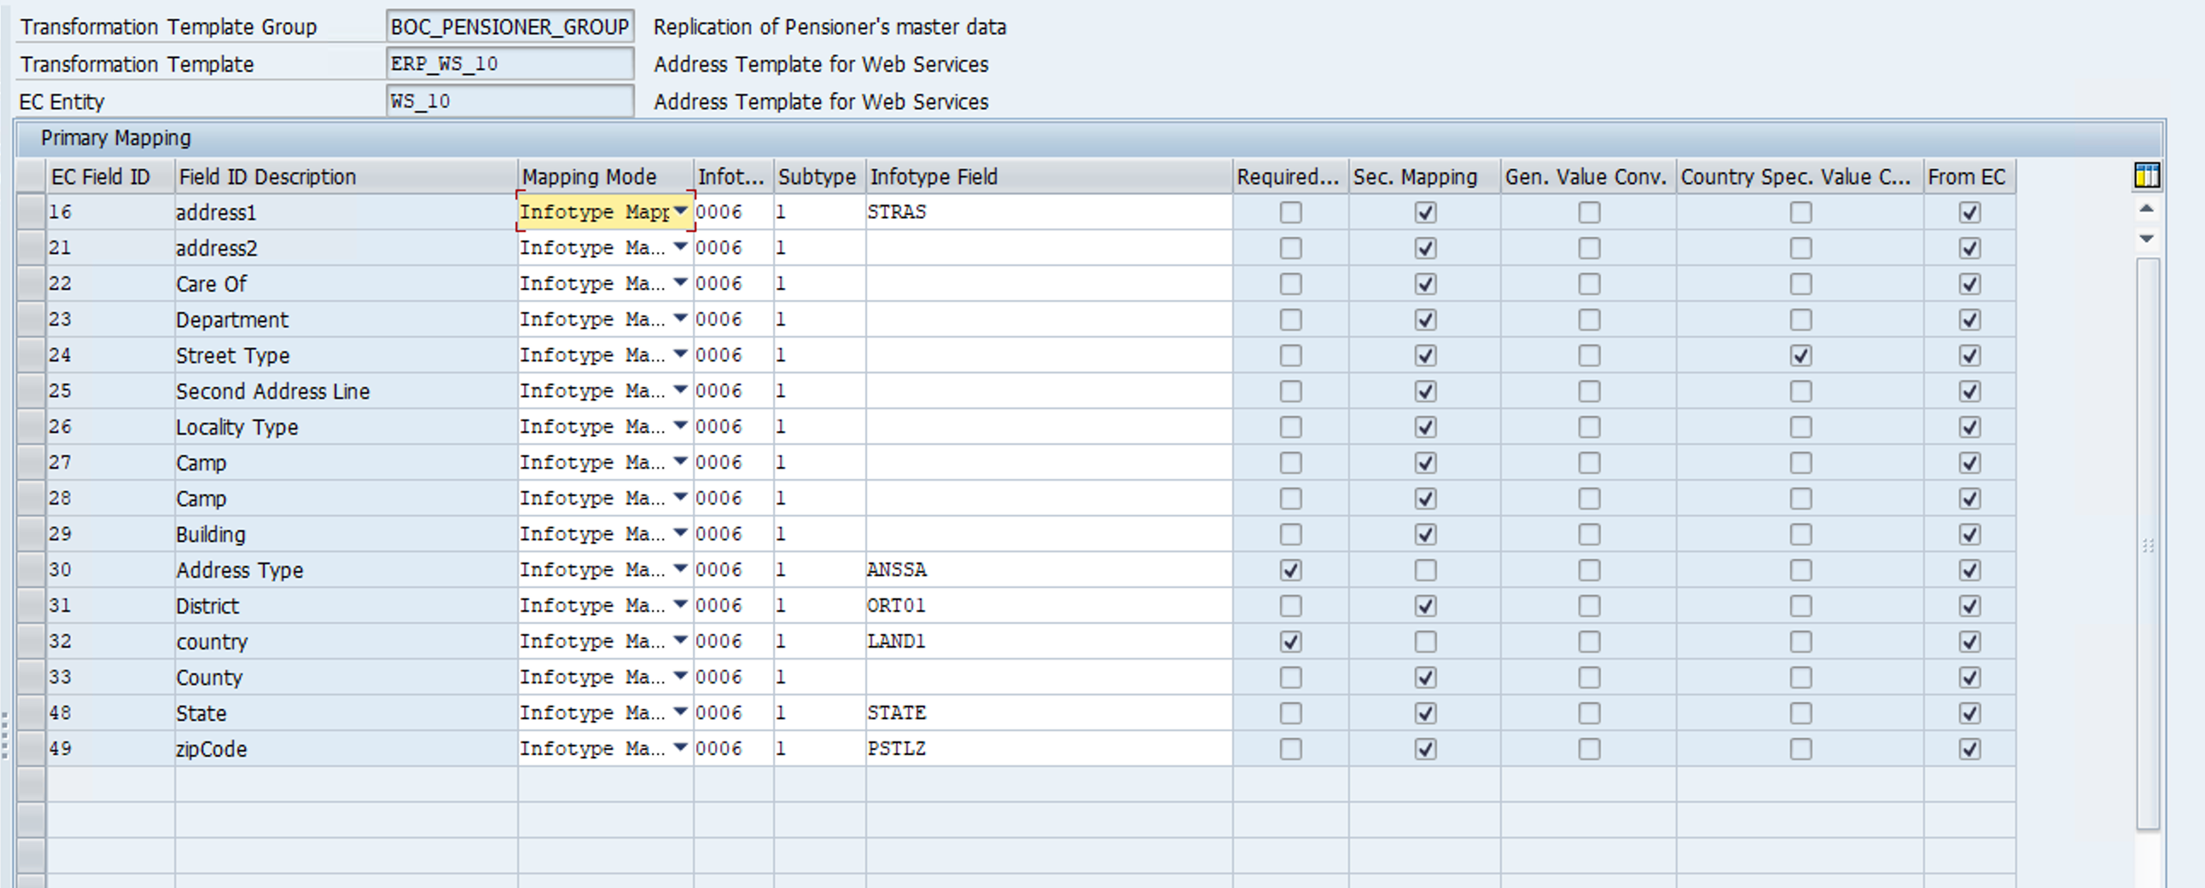
For secondary mapping please check detail in it0006
Ws11
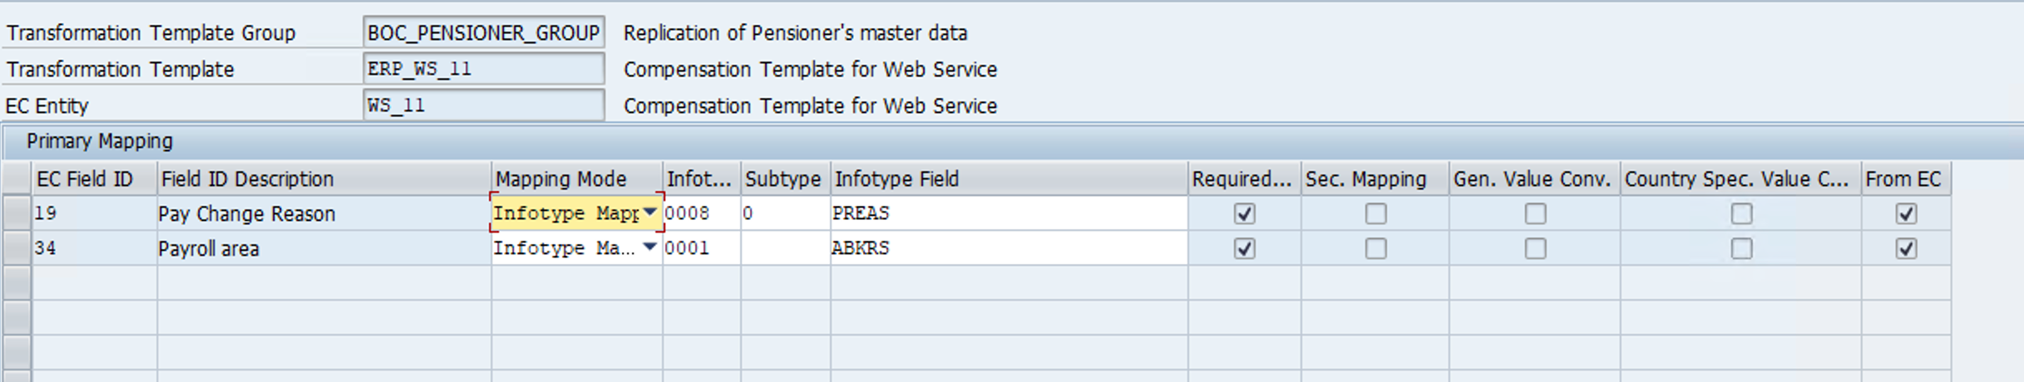
Ws 12
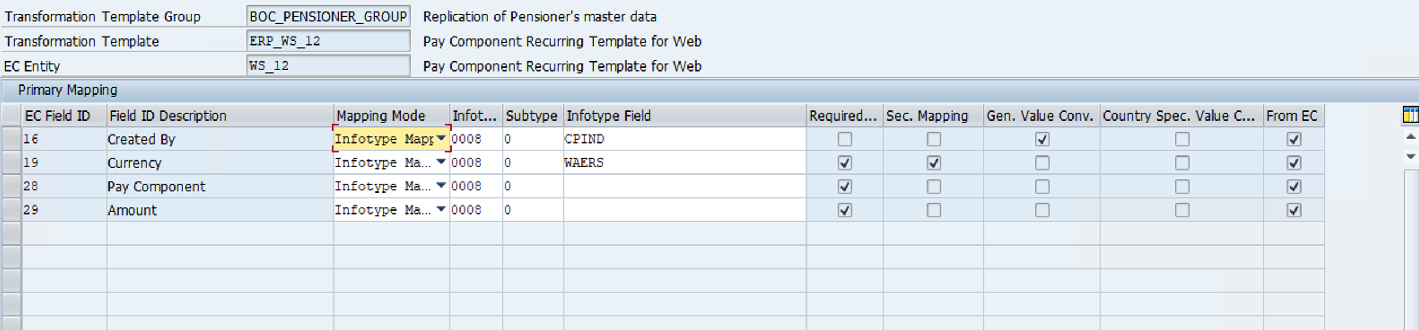

Ws14
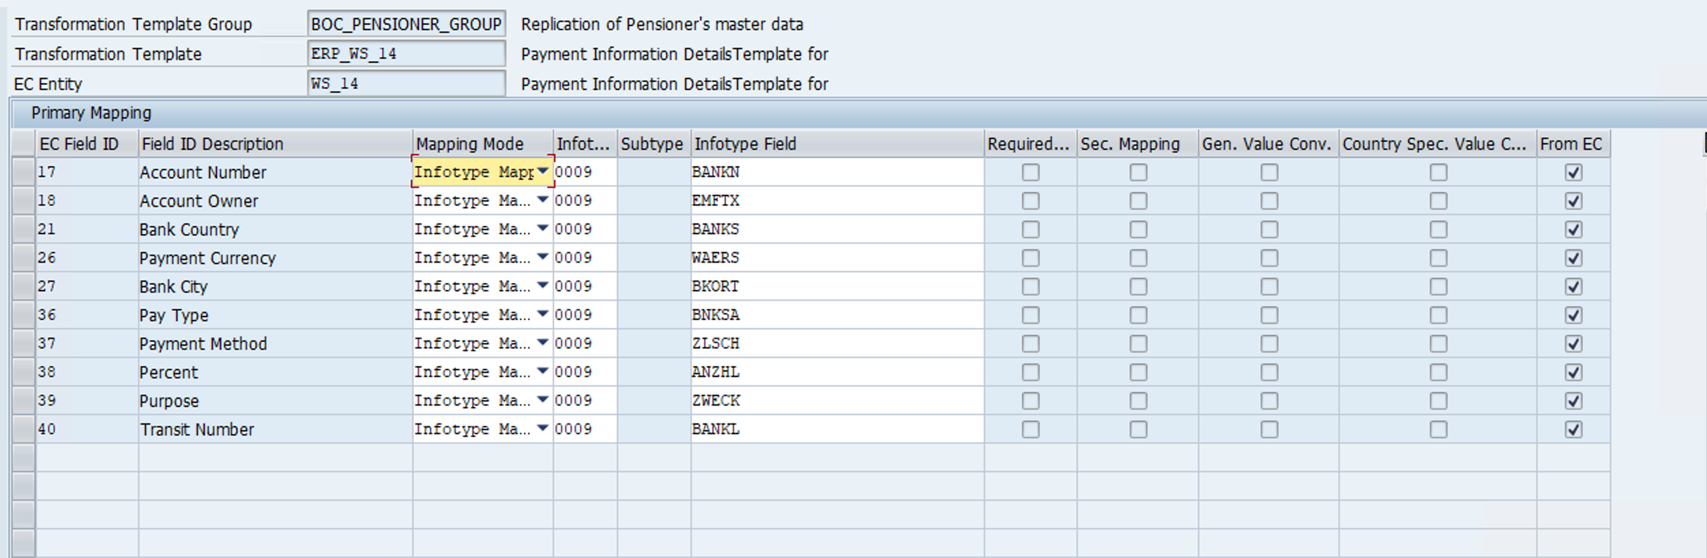
Ws17
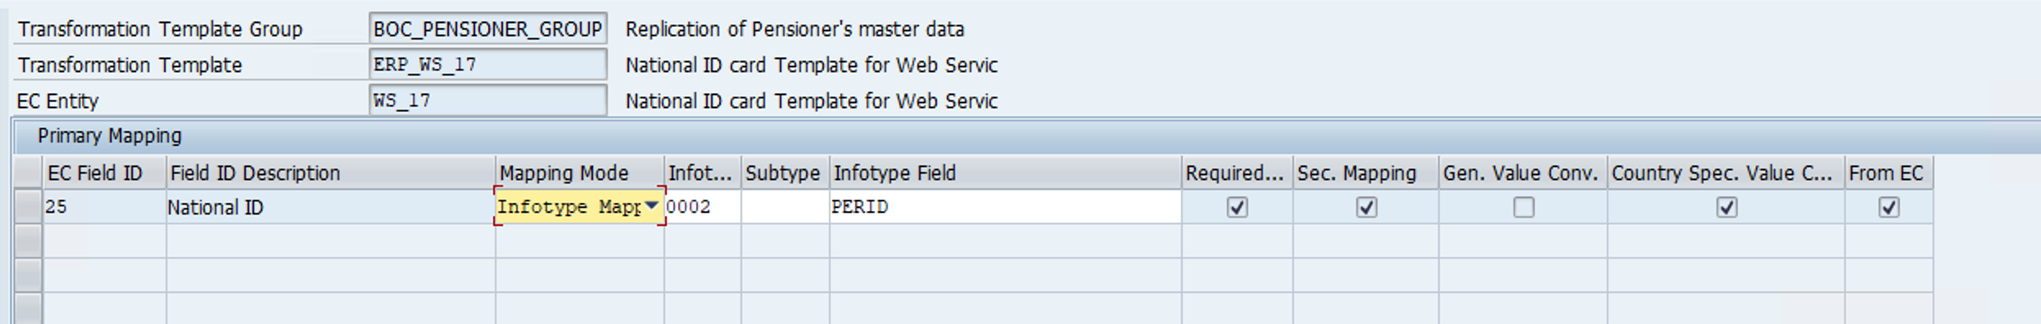
Ws2
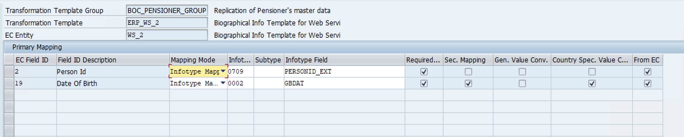

Ws3
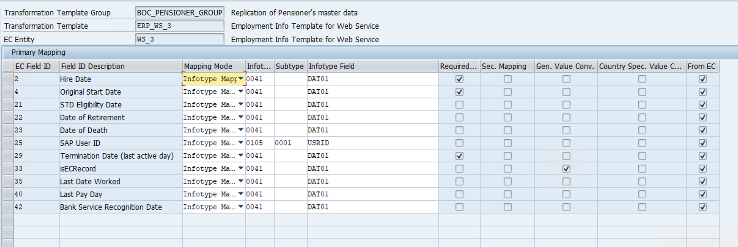

Ws4
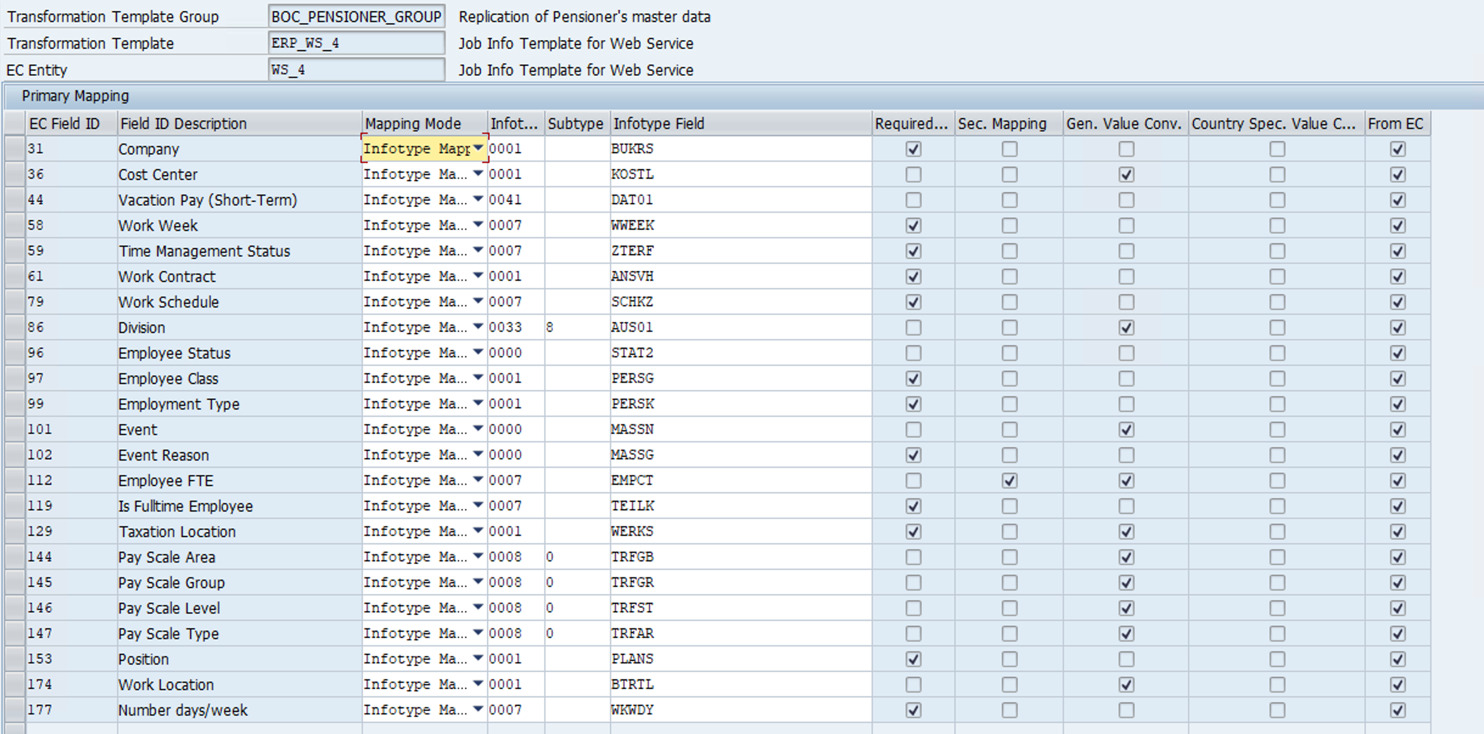
Ws5
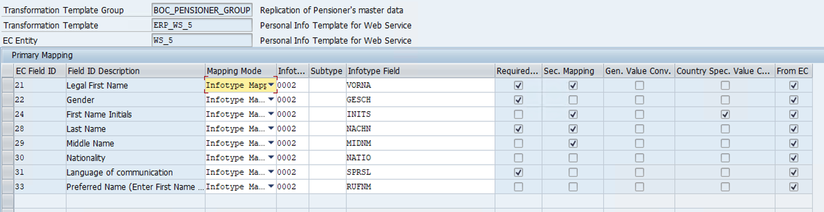
Ws7
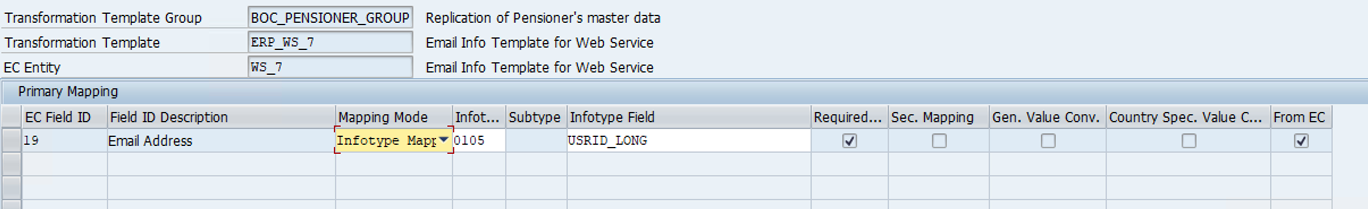
Ws8
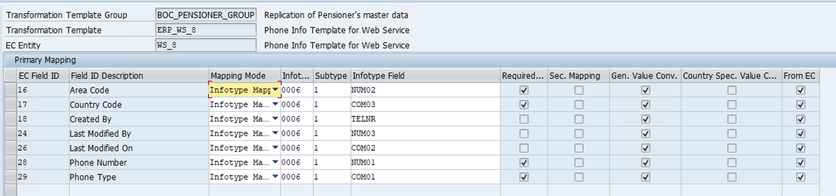
Ws9
